**Connect to the Store Sales Data and do the following: -**

− Remove all the blank rows.

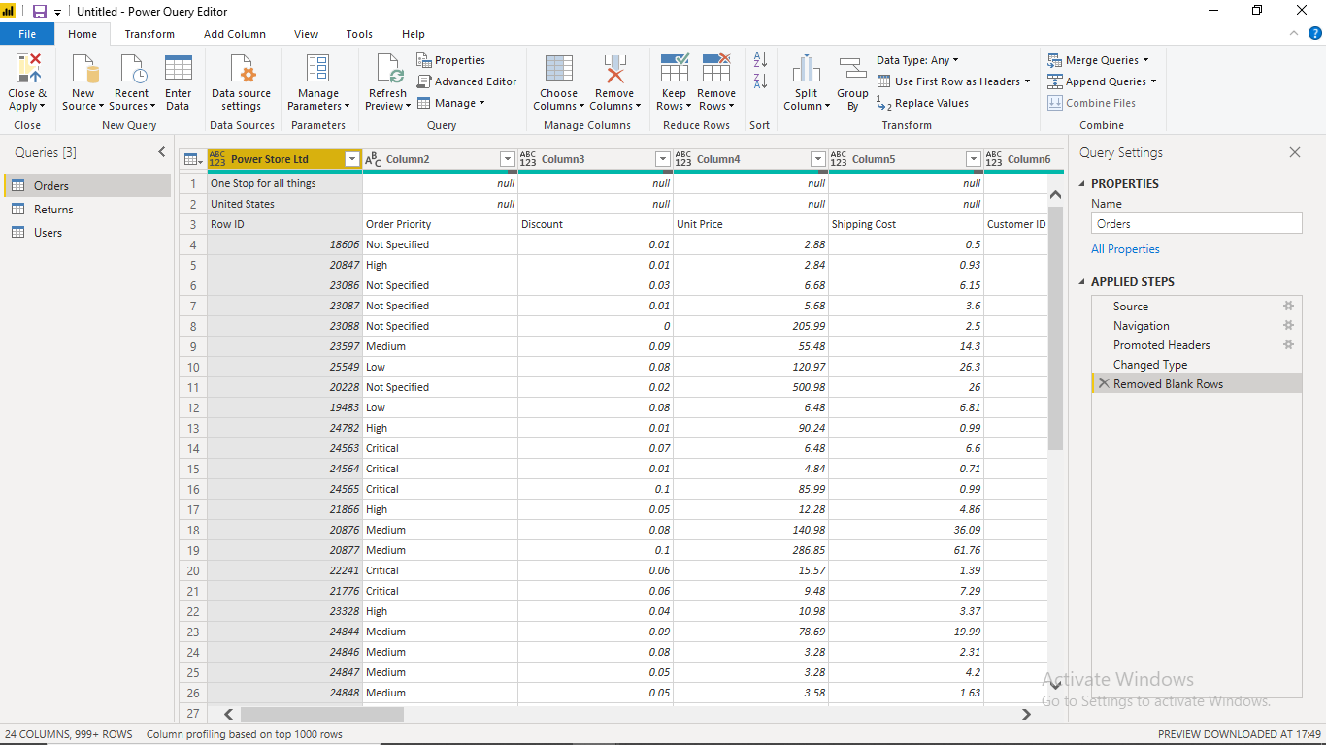

− Update the column header if they are not updated

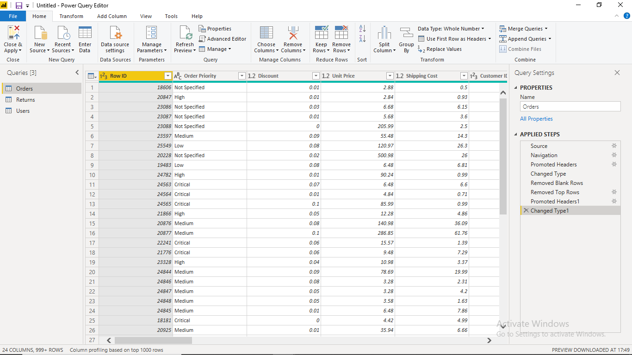

− Create a text table and show the sales in terms of

o Customers

o Product Category

o Regions

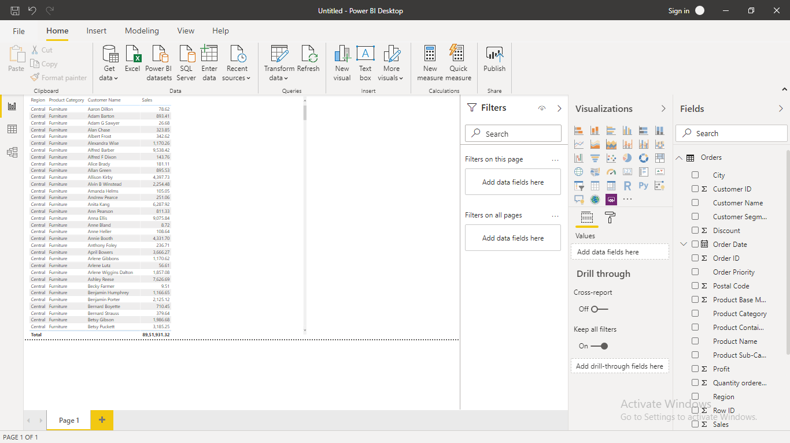

**Create a line and Clustered Column Chart showing the Sales and Discount as per the State or Province**

− Format the bars and line with different colors − Which state has the highest sales in terms Technology

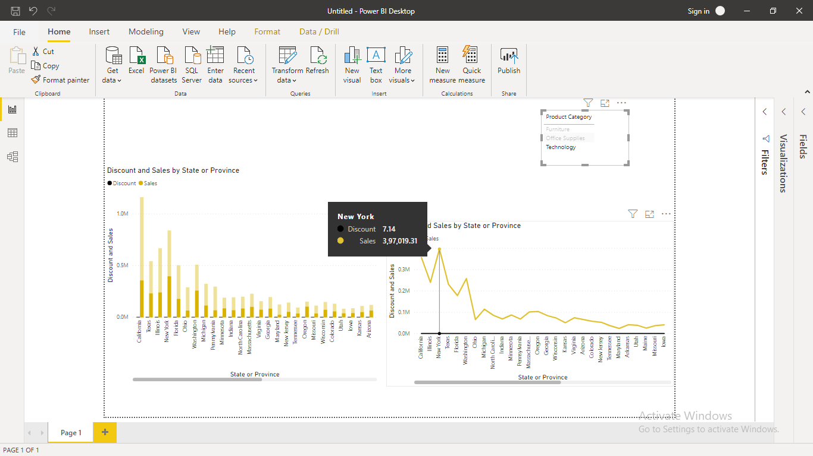

**New York state has the highest sales in terms Technology**

**Create a Donut Chart showing sales in terms of Product category**

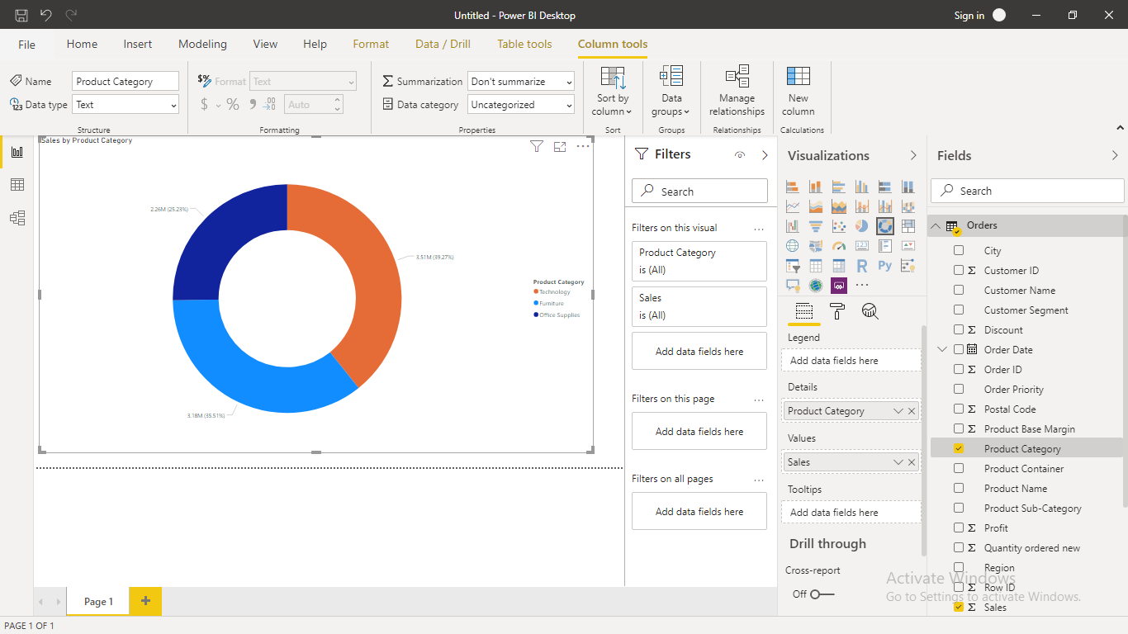

**• Create a Slicer and show the regions in dropdown. See how all the visuals mentioned above behaving when a particular region is selected.**

